Introduction to React JS :

Library kutli pn asude , at the end browser la fkt 3 goshti kaltat , HTML CSS JS

…. Shevti HTML CSS JS madhech sagla translate or render honar ahe

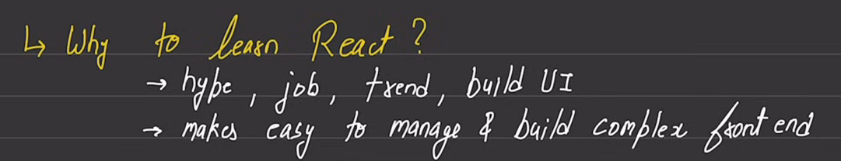

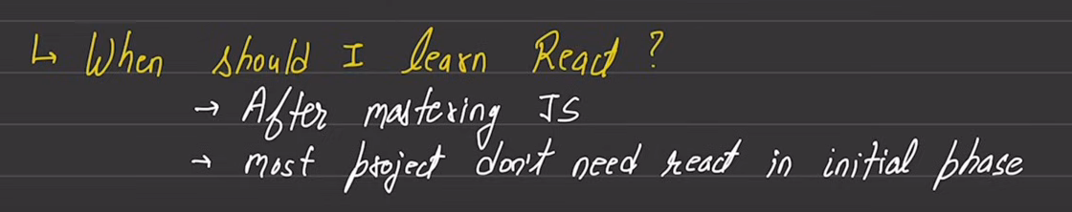

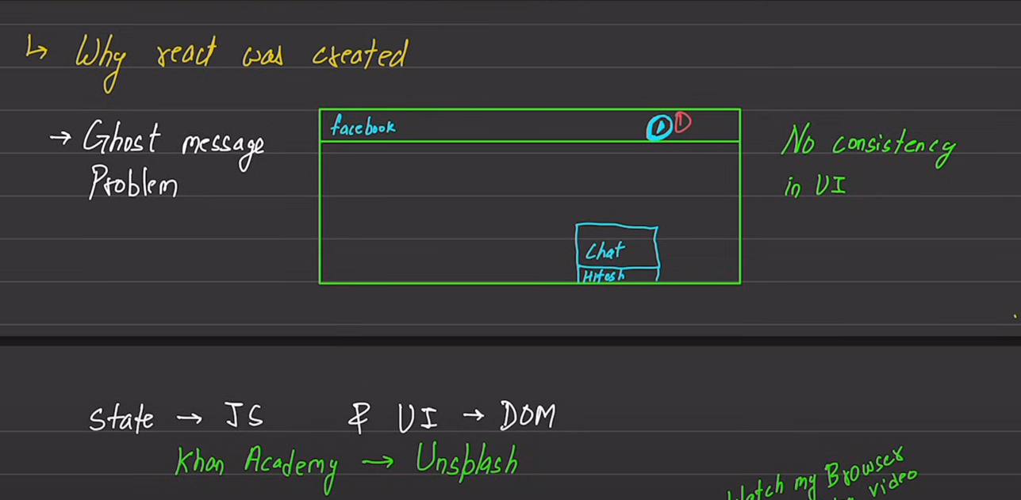

Some Foundation stuff:

What is a state?

It’s a fancy name given to the variables of JS

UI kon manage karate … DOM manage karata UI

**Tr state ani UI madhe synchronization pahije**

Historically Speaking : purvi UI ani state madhe proper sync nhvta so that problem was that UI consistency was not there

Pedagogy for learning React

The pedagogy which we are going to use is by making projects

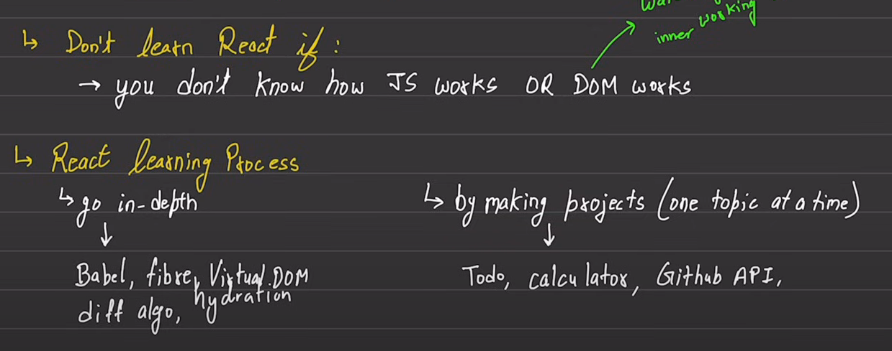

Library VS Framework

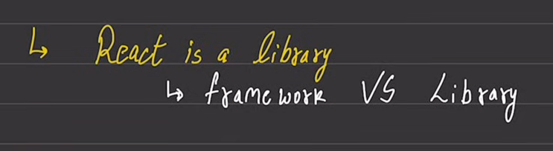

Topics flow:

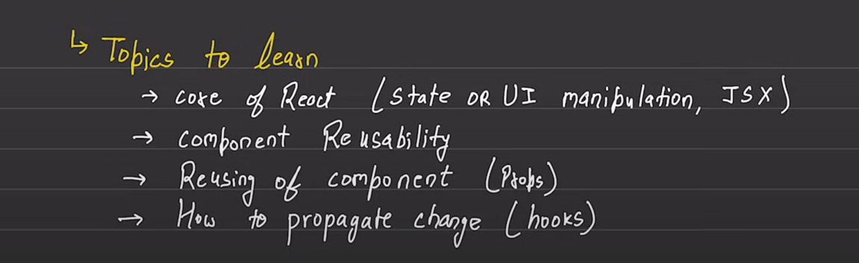

**JSX** means that JavaScript and HTML aapn ekatra lihu shaktoy..

**Props** means aapn properties pass karu shaktoy ..

**Hooks** – when we change or modify the variables , it is reflected via hooks.. bharpur hooks astat … its not necessary to study all of them … learning most frequently used hooks could be helpful …

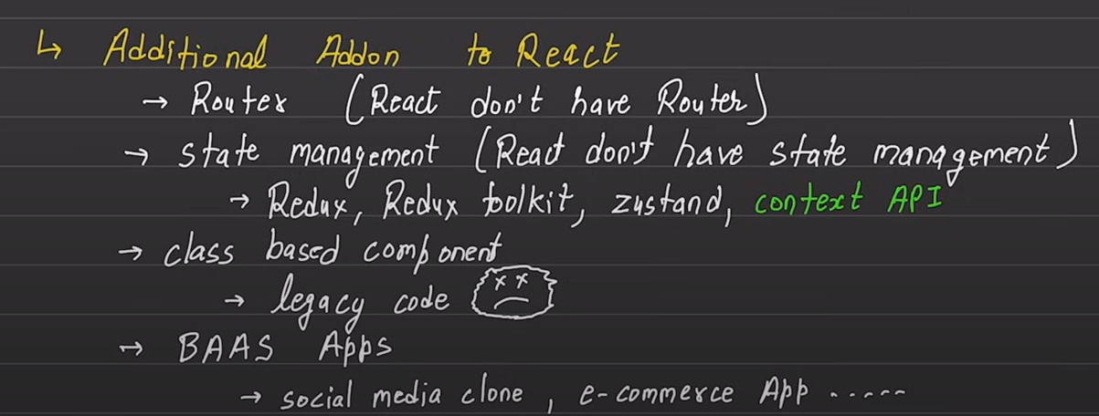

BAAS stands for backend as a service Apps

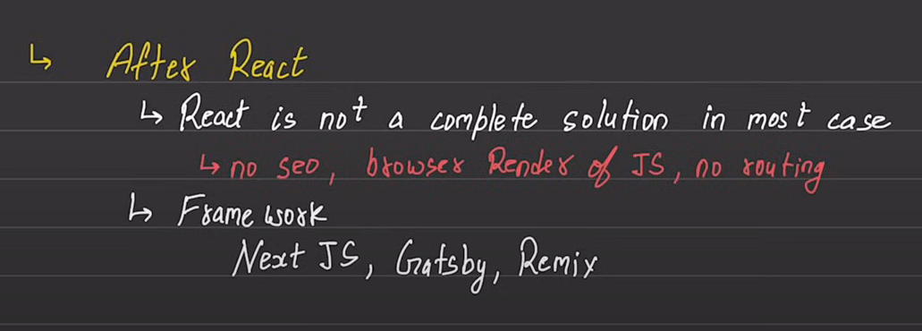

React ek core library ahe … If you desire to create websites then you have to use react with react – dom (another add on thing)

If you desire to create mobile apps then you have to use react with react – native (another add on thing)

The point is that React cha core knowledge use hotaach whether you are building web applications or you are building mobile applications

